YOUTH NEWS!!!!!!

September 2013
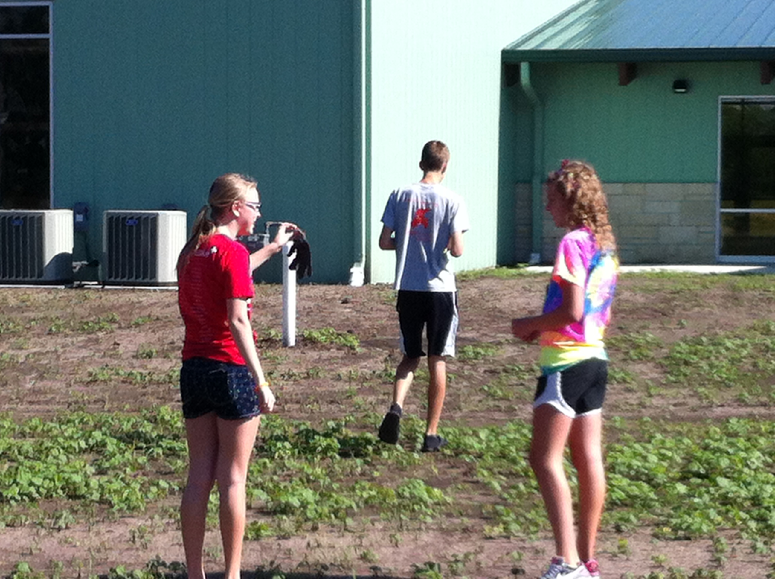

Sept 1st - NO YOUTH!!!! Labor Day weekend

Sept 8th - H2O Balloon War @ PHUMC

Sept 15th - Peer Pressure discussion @ PHUMC

Sept 22nd - Hiking meet at PHUMC at 3:45 and travel together to Iliff Commons

Sept 29th - Movie ‘Forgiveness theme’

*******Youth Council elections***** were held August 11th:

President – Leanna Knight Vice President – Ashleigh Crawshaw
Secretary – Andie Sodergren Treasurer – Zach Patton
Adco Representative – Joey Sodergren, Stryker Morgan, Daniel Holt
Youth council meets 1st Sunday from 4:30 to 5pm

SAVE THE DATE:

Oct 5th – TNO carnival
Nov 16th - Bishop’s Round-up for Hunger
8am-1:30pm Douglas County Fairgrounds
Jan 4-5th - The One Event

Youth Pastor
Michelle Caudill
785-224-3815
Rdh597@gmail.com

